SILVER CITY DAILY PRESS and Independent, FRIDAY MARCH 25, 2016 pg. 10
Silver City Elks help family with walking chair
Silver City Elks Lodge No. 413 donated a $3,000 walking chair to an area child with cerebral palsy on Thursday afternoon as part of the New Mexico Elks state project to raise funds for those with the disorder. Silver City Exalted Ruler Andrew Housley and Leading Knight Brock Nummerdor presented the specialized walking chair to Isaiah Castanon, 7, and his family Thursday evening as a way to give back to the community. Housley said that last year his lodge raised $3,200 for the state CP fund, and was pleased to see some of that money return to the community to purchase this specialized walker for Castanon. “You, as Elks, know our state major project is cerebral palsy. You’ve purchased rafﬂe tickets and probably done all sorts of things, and they’re dressed in green today because it’s Cerebral Palsy Awareness Day [on Friday],” he said. “What better day, because if you’ve been to our lodge meetings, you’ve known what we’ve been working on over the last couple of months is to help little Isaiah here. We’re adopting him — he’s going to be an Elk, that’s just all there is to it. We’re going to help this family just as we have all over the state.” Housley said he was glad to present this walker to Castanon and his family because it embodies what Elks do as a charitable organization. “Isaiah, this is yours, buddy. We’re gonna see you up and about, moving and walking,” Housley said during the Elks’ weekly dinner Thursday. “We’re so glad to have you, and we want to help you in any way we can.” Amy Castanon, Isaiah’s mother, said she is extremely grateful for what the Elks have done. “Our family would like to thank you all for supporting us and helping Isaiah get this walker. It means a lot,” she said. “For this to be given to us is — we can’t even express our gratitude because we are so happy.” Amy Castanon said this piece of equipment will give her son something that most people don’t even think about. “We take for granted walking every day, and this will help him and our family. We hope for him to walk one day,” she said. Friday “is actually Cerebral Palsy Awareness Day, but we celebrated today because of Good Friday at school. Central Elementary put on a day just for Isaiah and our family.”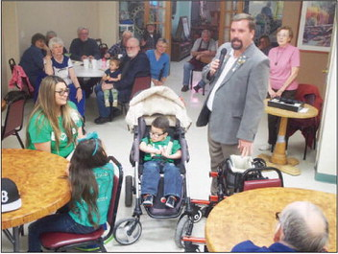
(Courtesy Photo) Silver City Elks Lodge Exalted Ruler Andrew Housley, right, presents a walking chair to Isaiah Castanon, 7, his mother, Amy, and his sister, Amiya, on Thursday evening as part of the New Mexico Elks’ state project to help those with cerebral palsy.

